- Write a program to sort the numbers
- Using insertion sort
- Print the number of comparisons or the number of times while loop runs for a given input.
- State whether for a particular input the time taken in best case, average case or worst case.

PROGRAM:-

#include<stdio.h>
#include<conio.h>

int a[50];
int count=0;
static int x;

int main()
{

int i, j, n;
int comp;
int temp,ptr;
printf("Enter the number of elements, :- ");
scanf("%d",&n);
printf("\n");
printf("Enter the array \n\n\n");
for(i=0;i<n;i++)
{
scanf("%d",&a[i]);
}

for(j=1;j<n;j++)
{
temp=a[j];
ptr=j-1;

while(++x && temp<a[ptr])
{
a[ptr+1]=a[ptr];
ptr=ptr-1;
count++;
}

a[ptr+1]=temp;
}

printf("\n\n\nThe sorted array is as follows\n\n");

for(i=0;i<n;i++)
{
printf("%3d", a[i]);
}

comp=(n*(n+1))/2;
printf("\n No of times the while loop runs is - %d \n \n",count);

if(count==0)
{

printf("The number of comparisions are %d \n",x);
printf("Best Case");
}
else
{
if(count==comp)
{
printf("the number of comparisions is %d \n",count);
printf("Worst Case");
}

if(count>0 && count<comp)
{
printf("the number of comparisions is %d \n",count);
printf("Average Case");
}
}

getch();

return 0;
}

OUTPUT:-

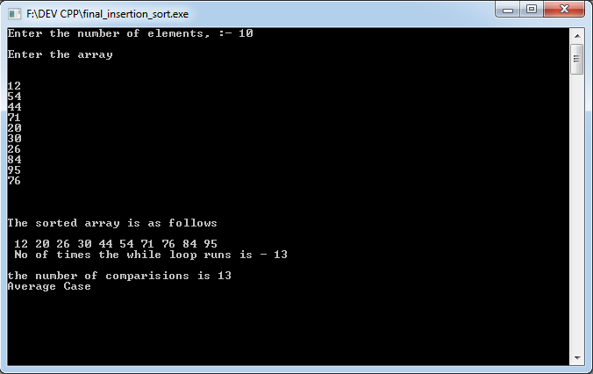

- Write a program to sort numbers
- Using divide and conquer approach mergesort
- Print the sequence of sorting
- For a given input find the number of times mergesort was called
- The number of times merge procedure runs

PROGRAM:-

#include<stdio.h>
#include<conio.h>

#define SIZE 50
int a[SIZE];
int b[SIZE];
int n;

static int x;
static int y;

void merge(int, int, int);
void mergesort(int, int);

void mergesort(int low, int high)
{
int mid;
x++;
if(low<high)
{
mid=(low+high)/2;
mergesort(low,mid);
mergesort(mid+1, high);
merge(low,mid,high);
}
}

void merge(int low, int mid, int high)
{
int h,i,j,k;
h=low;
i=low;
j=mid+1;
y++;
while(h<=mid&&j<=high)
{
if(a[h]<=a[j])
{
b[i]=a[h];
h=h+1;
}
else
{
b[i]=a[j];
j=j+1;
}
i=i+1;
}

if(h>mid)
{
for(k=j;k<=high;k++)
{
b[i]=a[k];
i=i+1;
}

}
else
{
for(k=h;k<=mid;k++)
{
b[i]=a[k];
i=i+1;
}
}

for(k=low;k<=high;k++)
a[k]=b[k];

printf("Round %d \n",x);

for(k=0;k<n;k++)
printf("%3d",a[k]);

printf("\n");
}

int main()
{

int low=0;
int high;
int i;

printf("Enter the size of array \n");
scanf("%d",&high);
n=high;
printf("Enter the array \n");

for(i=0;i<high;i++)
{
scanf("%d",&a[i]);
printf("\n");
}

mergesort(low,high-1);

for(i=0;i<high;i++)
{
printf("%3d",a[i]);
}

printf("\n");
printf("No of times mergesort procedure was called is %d", x);
printf("\n");
printf("No of times merge procedure was called is %d", y);
getch();
return 0;

}

OUTPUT:-

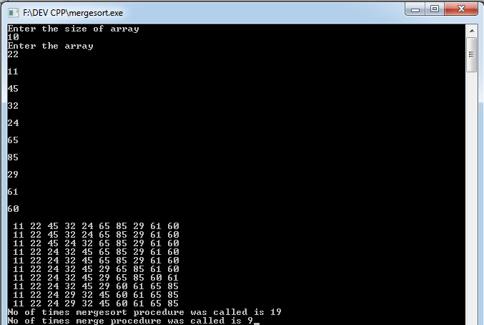

- Write a program to sort the numbers
- In increasing order using max heap

PROGRAM:-

#include<stdio.h>
#include<conio.h>

#define MAX 50
int a[MAX];

void insert(int len)
{
int i;
printf("Enter the elements \n");
for(i=1;i<=len;i++)
{
scanf("%d",&a[i]);
printf("\n");
}

}

void adjust(int i, int len)
{
int j=2*i;
int item=a[i];

while(j<=len)
{
if((j<len)&&(a[j]<a[j+1]))
j=j+1;
if(item>=a[j])
break;
a[j/2]=a[j];
j=2*j;
}
a[j/2]=item;
}

void heapify(int len)
{
int i;
for(i=(len/2);i>=1;i--)
{
adjust(i,len);
}

}

void heapsort(int len)
{
int i;
int temp;
int n=len;

for(i=len;i>=2;i--)
{
temp=a[i];
a[i]=a[1];
a[1]=temp;
n=n-1;
adjust(1,n);
}
}

int main()
{
int len;
int i;
printf("Enter the number of elements in the heap :-");
scanf("%d",&len);

printf("\n");

insert(len);

printf("The heap is as follows---------------------------------------- \n");
printf("\n");
heapify(len);

for(i=1;i<=len;i++)
printf("%5d",a[i]);

printf("\n");

heapsort(len);
printf("The sorted heap is as follows---------------------------------------- \n");
printf("\n");

for(i=1;i<=len;i++)
printf("%5d",a[i]);

getch();
return 0;
}

OUTPUT:-

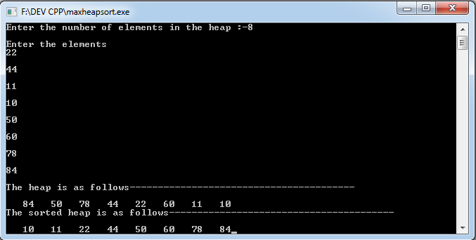

- In decreasing order using min heap

PROGRAM:-

#include<stdio.h>
#include<conio.h>

#define MAX 50
int a[MAX];

void insert(int len)
{
int i;
printf("Enter the elements \n");
for(i=1;i<=len;i++)
{
scanf("%d",&a[i]);
printf("\n");
}

}

void adjust(int i, int len)
{
int j=2*i;
int item=a[i];

while(j<=len)
{
if((j<len)&&(a[j]>a[j+1]))
j=j+1;
if(item<=a[j])
break;
a[j/2]=a[j];
j=2*j;
}
a[j/2]=item;
}

void heapify(int len)
{
int i;
for(i=(len/2);i>=1;i--)
{
adjust(i,len);
}

}

void heapsort(int len)
{
int i;
int temp;
int n=len;

for(i=len;i>=2;i--)
{
temp=a[i];
a[i]=a[1];
a[1]=temp;
n=n-1;
adjust(1,n);
}
}

int main()
{
int len;
int i;
printf("Enter the number of elements in the heap :-");
scanf("%d",&len);

printf("\n");

insert(len);

printf("The heap is as follows---------------------------------------- \n");
printf("\n");
heapify(len);

for(i=1;i<=len;i++)
printf("%5d",a[i]);

printf("\n");

heapsort(len);
printf("The sorted heap is as follows---------------------------------------- \n");
printf("\n");

for(i=1;i<=len;i++)
printf("%5d",a[i]);

getch();
return 0;
}

OUTPUT:-

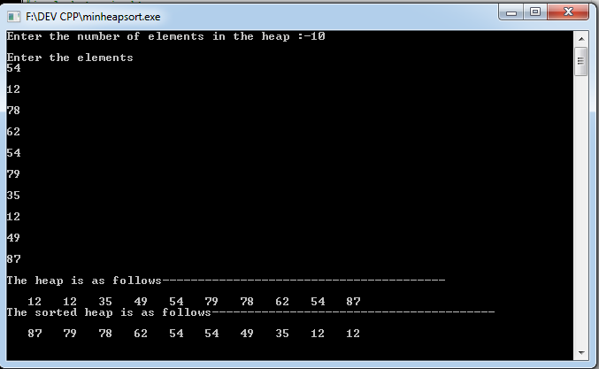

- Apply sorting techniques to sort the letters of your name. Find the number of comparisions for each and tell which is suitable

- Insertion Sort
- Mergesort
- Heapsort
- Quicksort

PROGRAM:-

#include<stdio.h>
#include<conio.h>
#include<string.h>
#define SIZE 50
char a[SIZE];
char m1[SIZE];
char m2[SIZE];
char h[SIZE];
char q[SIZE];
char ins[SIZE];
int n;
int nh;
static int x[4];

int flag[4];
void merge(int low, int mid, int high)
{
int h,i,j,k;
h=low;
i=low;
j=mid+1;

while(h<=mid&&j<=high)
{
if(m1[h]<=m1[j])
{
m2[i]=m1[h];
h=h+1;
x[1]++;
}
else
{
m2[i]=m1[j];
j=j+1;
x[1]++;
}
i=i+1;
}

if(h>mid)
{
x[1]++;
for(k=j;k<=high;k++)
{
m2[i]=m1[k];
i=i+1;
}

}
else
{
x[1]++;
for(k=h;k<=mid;k++)
{
m2[i]=m1[k];
i=i+1;
}
}

for(k=low;k<=high;k++)
m1[k]=m2[k];

printf("\n");
}

void mergesort(int low, int high)
{
int mid;

if(low<high)
{
mid=(low+high)/2;
mergesort(low,mid);
mergesort(mid+1, high);
merge(low,mid,high);
}
}
void call_merge()
{
int low=0;
int high;
/*int i;

printf("Enter the name \n");
gets(a);
*/

high=strlen(a);
n=high;

mergesort(low,high-1);

printf("\nThe sorted name according to merge sort is ");
puts(m1);

printf("No of comparirions in merge sort is %d \n",x[1]);
}

void MaxHeapify(char h[],int i)
{
int l,r,largest;
l=(2*i)+1;
r=(2*i)+2;
if(++x[2] && l<nh && h[l]>h[i])
largest=l;
else
largest=i;
if(++x[2] && r<nh && h[r]>h[largest])
largest=r;
if(largest!=i)
{
int temp;
temp=h[largest];
h[largest]=h[i];
h[i]=temp;
MaxHeapify(h,largest);
}
else
return;

}

void BuildMaxHeap(char h[])
{
for(int i=((nh/2)-1);i>=0;i--)
MaxHeapify(h,i);
}

void call_heap()
{
int size;
nh=strlen(h);
size=nh;
BuildMaxHeap(h);
for(int j=nh-1;j>0;j--)
{
int temp;
temp=h[0];
h[0]=h[j];
h[j]=temp;
nh=nh-1;
MaxHeapify(h,0);
}
printf("\nSorted name by heap sort: ");
puts(h);
printf("\nNo of comparisonsin heap sort: %d\n",x[2]);
}

int Partition(char a[],int p,int r)
{
int x1,i;
x1=q[r];
i=p-1;
for(int j=p;j<r;j++)
{
if(++x[3] && q[j]<=x1)
{
i=i+1;
int temp;
temp=q[i];
q[i]=q[j];
q[j]=temp;
}
}
int temp;
temp=q[r];
q[r]=q[i+1];
q[i+1]=temp;
return i+1;
}

void QuickSort(char a[],int p,int r)
{
int q;
if(p<r)
{
q=Partition(a,p,r);
QuickSort(a,p,q-1);
QuickSort(a,q+1,r);
}
}

void call_quick()
{
int n;

n=strlen(q);
QuickSort(a,0,n-1);
printf("\nSorted name by quick sort is: ");
puts(q);
printf("\nNo. of comparisons in quick sort is: %d \n",x[3]);
}

void call_insertion()
{
int num,i=0,j=0,count=0;

char temp;
num=strlen(ins);
for(i=1;ins[i]!='\0';i++)
{
temp=ins[i];
j=i-1;

while((temp<ins[j]) && (j>=0))
{
count++;
ins[j+1]=ins[j];
j=j-1;
x[0]++;
}
ins[j+1]=temp;
}
printf("\n The sorted name according to Insertion sort is : ");
puts(ins);
printf("\n The number of comparisions in insertion sort is %d \n",x[0]);
}

int main()
{

int min;
int i;
printf("Enter the name \n");
gets(a);

strcpy(m1,a);
strcpy(h,a);
strcpy(q,a);
strcpy(ins,a);

call_merge();
call_heap();
call_quick();
call_insertion();

min=0;

for(i=1;i<4;i++)
{s
if(x[min]>x[i])
min=i;
}

for(i=0;i<4;i++)
{
if(x[min]==x[i])
{
flag[i]=1;
}
}

if(flag[0]==1)
printf("\nInsertion Sort is Best\n");

if(flag[1]==1)
printf("\nMerge Sort is Best\n");

if(flag[2]==1)
printf("\nHeap Sort is Best\n");

if(flag[3]==1)
printf("\nQuick Sort is Best\n");
getch();
return 0;
}

OUTPUT:-

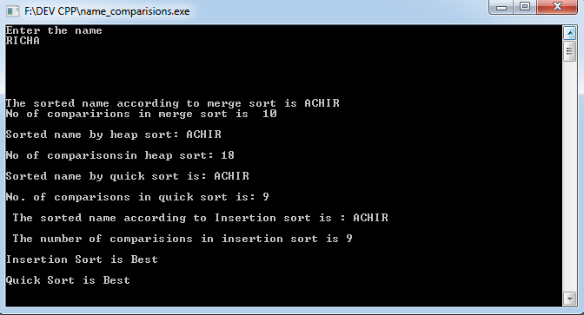

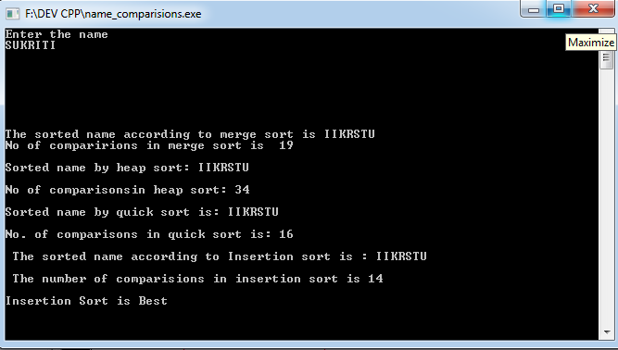

5. Write a program to search element in array
- Using linear search
- Using binary search

LINEAR SEARCH
#include<stdio.h>
#include<conio.h>
#include<malloc.h>
using namespace std;
main()
{
int *a,n,i,search,p=0;
printf("Enter number of elements in array");
scanf("%d",&n);
printf("Enter elements of array");
a=(int*)malloc(n*2);
for(i=0;i<n;i++)
scanf("%d",&a[i]);
printf("Enter element to search");
scanf("%d",&search);
for(i=0;i<n;i++)
{
if(a[i]==search)
{
p=1;
printf("Element found at position %d",i+1);
break;
}
}
if(p==0)
printf("Element not present in the array");
getch();
}
OUTPUT

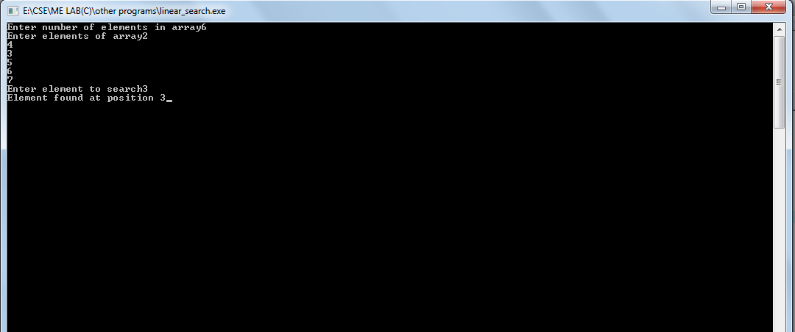

BINARY SEARCH
#include<stdio.h>
#include<conio.h>
#include<malloc.h>
using namespace std;
main()
{
int *a,n,search,i,mid,start,end;
printf("Enter number of elements in array");
scanf("%d",&n);
printf("Enter elements of sorted array");
a=(int*)malloc(n*2);
for(i=0;i<n;i++)
scanf("%d",&a[i]);
printf("Enter element to search");
scanf("%d",&search);
start=0;
end=n-1;
mid=(start+end)/2;
while(start<=end)
{
if(search>a[mid])
start=mid+1;
else if(search==a[mid])
{
printf("Element found at position %d",mid+1);
break;
}
else
end=mid-1;
mid=(start+end)/2;
}
if(start>end)
printf("Element not present in the array");
getch();
}
OUTPUT
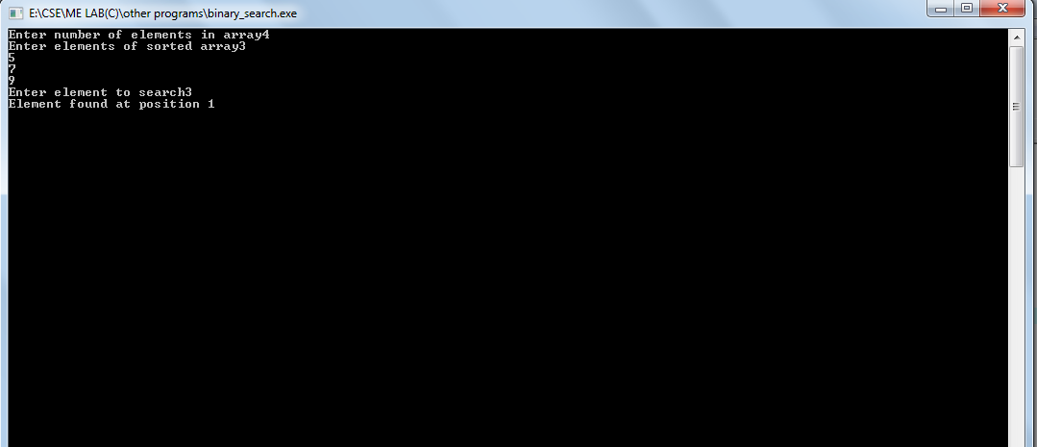

ASSIGNMENT-3
1. Implement Btree of min degree of t=2 and insert the elements:
14 21 13 17 11 5 31 28 19 5 45 7
#include <stdio.h>
#include <stdlib.h>
#define MAX 3
#define MIN 1

struct btreeNode {
int val[MAX + 1], count;
struct btreeNode *link[MAX + 1];
};

struct btreeNode *root;

/* creating new node */
struct btreeNode * createNode(int val, struct btreeNode *child) {
struct btreeNode *newNode;
newNode = (struct btreeNode *)malloc(sizeof(struct btreeNode));
newNode->val[1] = val;
newNode->count = 1;
newNode->link[0] = root;
newNode->link[1] = child;
return newNode;
}

/* sets the value val in the node */

/* Places the value in appropriate position */
void addValToNode(int val, int pos, struct btreeNode *node,
struct btreeNode *child) {
int j = node->count;
while (j > pos) {
node->val[j + 1] = node->val[j];
node->link[j + 1] = node->link[j];
j--;
}
node->val[j + 1] = val;
node->link[j + 1] = child;
node->count++;
}

/* split the node */
void splitNode (int val, int *pval, int pos, struct btreeNode *node,
struct btreeNode *child, struct btreeNode **newNode) {
int median, j;

if (pos > MIN)
median = MIN + 1;
else
median = MIN;

*newNode = (struct btreeNode *)malloc(sizeof(struct btreeNode));
j = median + 1;
while (j <= MAX) {
(*newNode)->val[j - median] = node->val[j];
(*newNode)->link[j - median] = node->link[j];
j++;
}
node->count = median;
(*newNode)->count = MAX - median;

if (pos <= MIN) {
addValToNode(val, pos, node, child);
} else {
addValToNode(val, pos - median, *newNode, child);
}
*pval = node->val[node->count];
(*newNode)->link[0] = node->link[node->count];
node->count--;
}

int setValueInNode(int val, int *pval,
struct btreeNode *node, struct btreeNode **child) {

int pos;
if (!node) {
*pval = val;
*child = NULL;
return 1;
}

if (val < node->val[1]) {
pos = 0;
} else {
for (pos = node->count;
(val < node->val[pos] && pos > 1); pos--);
if (val == node->val[pos]) {
printf("Duplicates not allowed\n");
return 0;
}
}
if (setValueInNode(val, pval, node->link[pos], child)) {
if (node->count < MAX) {
addValToNode(*pval, pos, node, *child);
} else {
splitNode(*pval, pval, pos, node, *child, child);
return 1;
}
}
return 0;
}

/* insert val in B-Tree */
void insertion(int val) {
int flag, i;
struct btreeNode *child;

flag = setValueInNode(val, &i, root, &child);
if (flag)
root = createNode(i, child);
}

/* B-Tree Traversal */
void traversal(struct btreeNode *myNode) {
int i;
//printf("%d ", myNode->val[i + 1]);
if (myNode) {
for (i = 0; i < myNode->count; i++) {
//printf("%d ", myNode->val[i + 1]);
traversal(myNode->link[i]);
printf("%d ", myNode->val[i + 1]);
}
traversal(myNode->link[i]);
}
}

int main() {
int val, ch,i,j,num,int1;
insertion(14);
insertion(21);
insertion(13);
insertion(17);
insertion(11);
insertion(5);
insertion(31);
insertion(28);
insertion(19);
insertion(5);
insertion(45);
insertion(7);
printf("\nChoose from the following:\n");
while (1) {
printf("1. Insert a new value\n");
printf("2. Check the inserted values\n");
printf("3. Exit\nEnter your choice:");
scanf("%d", &ch);
switch (ch) {
case 1:
printf("Enter the new Value:");
scanf("%d", &val);
insertion(val);
break;
case 2:
traversal(root);
break;
case 3:
exit(0);
default:
printf("U have entered wrong option!!\n");
break;
}
printf("\n");
}
}
OUTPUT

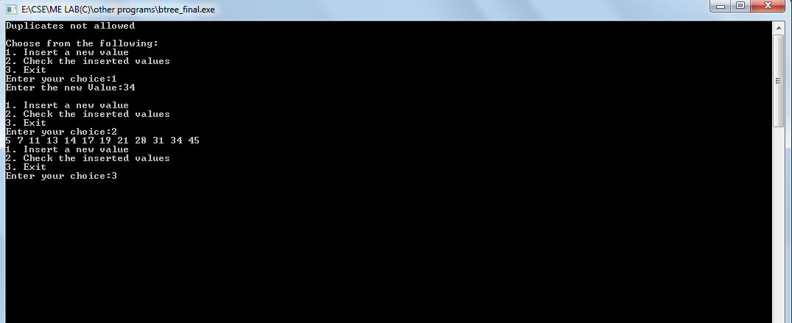

2. Write function in C language which counts the no of node in above Btree and give the level of leaf nodes.
#include <stdio.h>
#include <stdlib.h>
#define MAX 3
#define MIN 1

struct btreeNode
{
int val[MAX + 1], count;
struct btreeNode *link[MAX + 1];

};
struct btreeNode *root;
int ncount;
int leaf[50];
/* creating new node */
struct btreeNode * createNode(int val, struct btreeNode *child) {
struct btreeNode *newNode;
newNode = (struct btreeNode *)malloc(sizeof(struct btreeNode));
newNode->val[1] = val;
newNode->count = 1;
newNode->link[0] = root;
newNode->link[1] = child;
return newNode;
}
/* sets the value val in the node */
/* Places the value in appropriate position */
void addValToNode(int val, int pos, struct btreeNode *node, struct btreeNode *child)
{
int j = node->count;
while (j > pos)
{
node->val[j + 1] = node->val[j];
node->link[j + 1] = node->link[j];
j--;
}
node->val[j + 1] = val;
node->link[j + 1] = child;
node->count++;
}

/* split the node */
void splitNode (int val, int *pval, int pos, struct btreeNode *node,
struct btreeNode *child, struct btreeNode **newNode) {
int median, j;

if (pos > MIN)
median = MIN + 1;
else
median = MIN;

*newNode = (struct btreeNode *)malloc(sizeof(struct btreeNode));
//ncount++;
j = median + 1;
while (j <= MAX) {
(*newNode)->val[j - median] = node->val[j];
(*newNode)->link[j - median] = node->link[j];

j++;
}
node->count = median;
(*newNode)->count = MAX - median;
//ncount++;
if (pos <= MIN) {
addValToNode(val, pos, node, child);
} else {
addValToNode(val, pos - median, *newNode, child);
}
*pval = node->val[node->count];
(*newNode)->link[0] = node->link[node->count];
node->count--;
}
int setValueInNode(int val, int *pval,
struct btreeNode *node, struct btreeNode **child) {

int pos;
if (!node) {
*pval = val;
*child = NULL;
return 1;
}
if (val < node->val[1]) {
pos = 0;
} else {
for (pos = node->count;
(val < node->val[pos] && pos > 1); pos--);
if (val == node->val[pos]) {
printf("Duplicates not allowed\n");
return 0;
}
}
if (setValueInNode(val, pval, node->link[pos], child)) {
if (node->count < MAX) {
addValToNode(*pval, pos, node, *child);
} else {
splitNode(*pval, pval, pos, node, *child, child);
return 1;
}
}
return 0;
}
/* insert val in B-Tree */
void insertion(int val) {
int flag, i;
struct btreeNode *child;
flag = setValueInNode(val, &i, root, &child);
if (flag)
root = createNode(i, child);
}

/* B-Tree Traversal */
void traversal(struct btreeNode *myNode) {
int i;
if (myNode) {
for (i = 0; i < myNode->count; i++) {
traversal(myNode->link[i]);

printf("%d ", myNode->val[i + 1]);
}
traversal(myNode->link[i]);
ncount++ ;
}

}
void lowleaf(struct btreeNode *myNode) {
int i;

for (i = 0; i < myNode->count+1; i++)
{
if((myNode->link[i]))
{
leaf[i]++;
lowleaf(myNode->link[i]);
}
//printf("%d ", myNode->val[i + 1]);
}
}
int main() {
int val, ch,i,j,num,int1;
insertion(14);
insertion(21);
insertion(13);
insertion(17);
insertion(11);
insertion(5);
insertion(31);
insertion(28);
insertion(19);
insertion(5);
insertion(45);
insertion(7);
printf("\nChoose from the following:\n");
while (1) {
printf("1. Insert a new value\n");
printf("2. Check the inserted values\n");
printf("3. Exit\nEnter your choice:");
scanf("%d", &ch);
switch (ch) {
case 1:
printf("Enter the old Value:");
scanf("%d", &val);
insertion(val);
break;
case 2:
traversal(root);
printf("\n The Number of nodes in the tree are %d \n",ncount);
ncount=0;
lowleaf(root);
for (i = 0; i < root->count + 1; i++) printf("\nBranch %d leaf %d",i,leaf[i]);
for (i = 0; i < root->count + 1; i++) leaf[i] = 0;
break;
case 3:
exit(0);
default:
printf("U have entered wrong option!!\n");
break;
}
printf("\n");
}
}

OUTPUT:

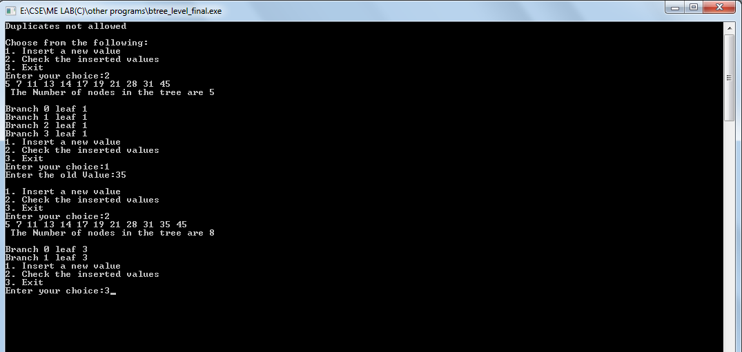

3. For the graph G which is represented
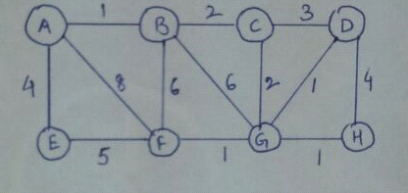
- Store the graph using suitable data structure
- Find the minimum spanning tree using Kruskal and Prim algorithm
- Print the order in which edges are added in both the methods

KRUSKAL ALGORITHM

#include<stdio.h>
#include<conio.h>
#include<stdlib.h>
int i,j,k,a,b,u,v,n,ne=1;
int min,mincost=0,cost[9][9],parent[9];
int find(int);
int uni(int,int);
int main()
{
//clrscr();
printf("***KRUSKAL’S ALGORITHM FOR MINIMUM SPANNING TREE (MST) ****");
//printf("KRUSKAL’S ALGORITHM FOR MINIMUM SPANNING TREE (MST) ****\n");
printf("\nEnter the No. of Vertices: \n");
scanf("%d",&n);
printf("\nEnter the Cost Adjacency Matrix\n");
for(i=1;i<=n;i++)
{
for(j=1;j<=n;j++)
{
scanf("%d",&cost[i][j]);
if(cost[i][j]==0)
cost[i][j]=999;
}
}
printf("\n*** FINAL MST ***");
printf("\n The Edges of Minimum Cost Spanning Tree are\n");
while(ne<n)
{
for(i=1,min=999;i<=n;i++)
{
for(j=1;j<=n;j++)
{
if(cost[i][j]<min)
{
min=cost[i][j];
a=u=i;
b=v=j;
}
}
}
u=find(u);
v=find(v);
if(uni(u,v))
{
printf("\n%d Edge (%d,%d) = %d",ne++,a,b,min);
mincost +=min;
}
cost[a][b]=cost[b][a]=999;
}
printf("\n Minimum Cost = %d\n",mincost);
return mincost;
getch();
}

int find(int i)
{
while(parent[i])
i=parent[i];
return i;
}

int uni(int i,int j)
{
if(i!=j)
{
parent[j]=i;
return 1;
}
return 0;
}

OUTPUT
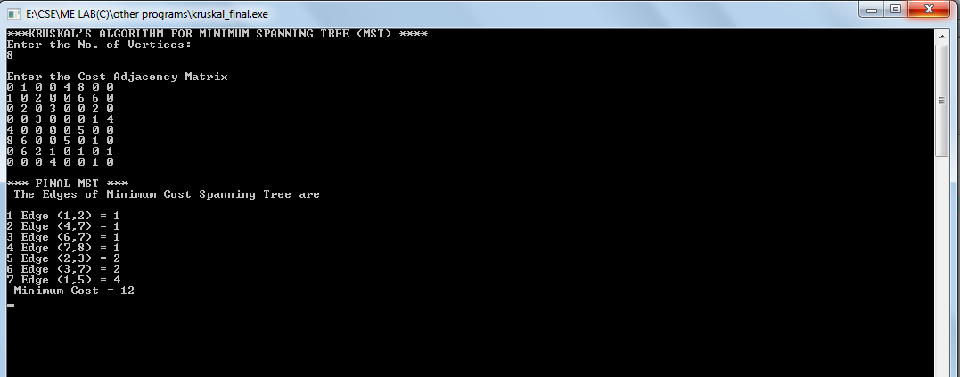

PRIM’S ALGORITHM
#include<stdio.h>
#include<conio.h>
int a,b,u,v,n,i,j,ne=1;
int visited[10]={0},min,mincost=0,cost[10][10];
int main()
{
// clrscr();
printf("\n Enter the number of nodes:");
scanf("%d",&n);
printf("\n Enter the adjacency matrix:\n");
for(i=1;i<=n;i++)
for(j=1;j<=n;j++)
{
scanf("%d",&cost[i][j]);
if(cost[i][j]==0)
cost[i][j]=999;
}
visited[1]=1;
printf("\n");
while(ne<n)
{
for(i=1,min=999;i<=n;i++)
for(j=1;j<=n;j++)
if(cost[i][j]<min)
if(visited[i]!=0)
{
min=cost[i][j];
a=u=i;
b=v=j;
}
if(visited[u]==0 || visited[v]==0)
{
printf("\n Edge %d:(%d %d) cost:%d",ne++,a,b,min);
mincost+=min;
visited[b]=1;
}
cost[a][b]=cost[b][a]=999;
}
printf("\n Minimun cost=%d",mincost);
getch();
return 0;
}

OUTPUT
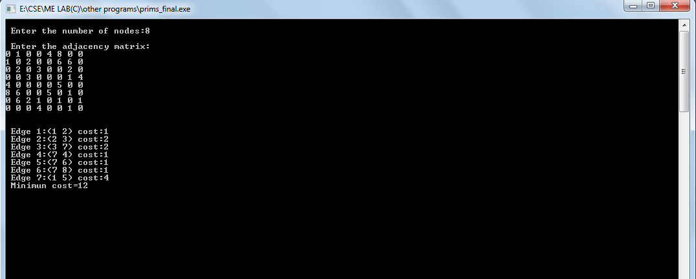

4: For the above graph:
- Use breadth first search and printer the order of visiting nodes
- Implement depth first search and also print the traversal of vertices.

BREADTH FIRST SEARCH

#include<stdio.h>
#include<conio.h>
#include<stdlib.h>
int cost[10][10],i,j,k,n,qu[10],front,rare,v,visit[10],visited[10];
int main()
{
//clrscr();
int m;
printf("enter no of vertices");
scanf("%d",&n);
printf("enter no of edges\t");
scanf("%d",&m);
printf("\nEDGES \n");
for(k=1;k<=m;k++)
{
scanf("%d %d",&i,&j);
cost[i][j]=1;
}

printf("enter initial vertex\t");
scanf("%d",&v);
printf("Visitied vertices\n");
printf(v +" ");
visited[v]=1;
k=1;
while(k<n)
{
for(j=1;j<=n;j++)
if(cost[v][j]!=0 && visited[j]!=1 && visit[j]!=1)
{
visit[j]=1;
qu[rare++]=j;
}
v=qu[front++];
printf(v +" ");
k++;
visit[v]=0; visited[v]=1;
}
getch();
}

OUTPUT
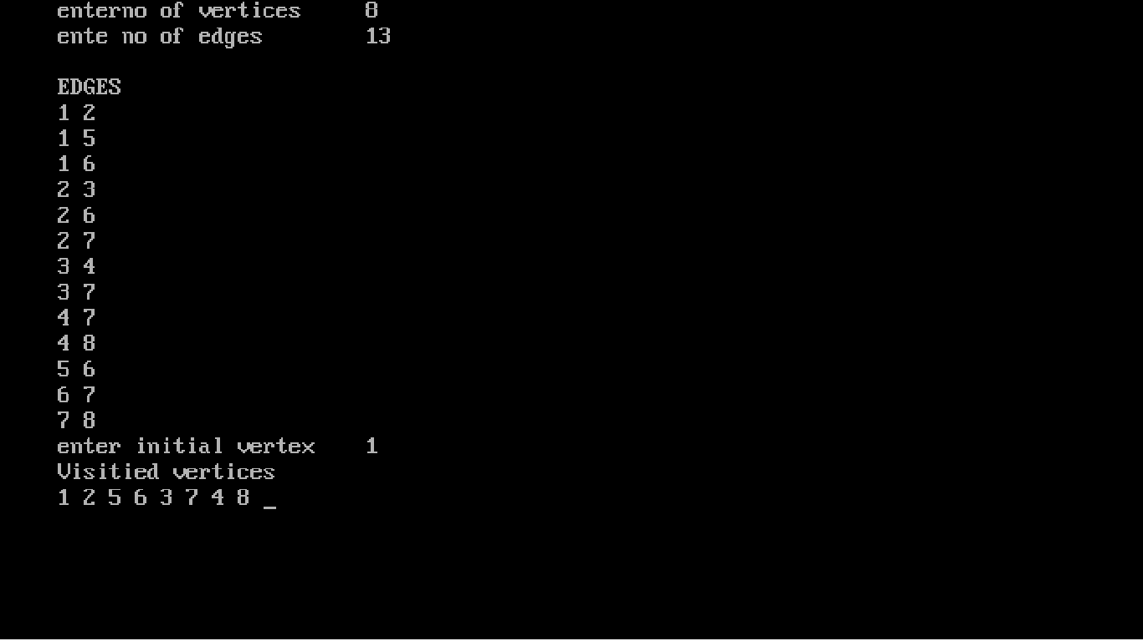
DEPTH FIRST SEARCH
#include<stdio.h>
#include<conio.h>

char stack[20];
int top=-1, n;
char arr[20];
char dfs(int );
char ajMat[20][20];
char b[20];
void display();
int p=0;

int main()
{
char v;
int l=0;
printf("Enter the number of nodes in a graph");
scanf("%d",&n);
printf("Enter the value of node of graph");
for(int i=0; i<n; i++)
{
scanf("%s",&b[i]);
}
char k=b[0];
printf("Enter the value in adjancency matrix in from of 'Y' or 'N'\n");
printf("\nIf there is an edge between the two vertices then enter 'Y' or 'N'\n");
for(int i=0; i<n; i++)
printf(" %c ",b[i]);
for(int i=0;i<n; i++)
{
printf("\n%c ",b[i]);
for(int j=0; j<n; j++)
{
printf("%c ",v=getch());
ajMat[i][j]=v;
}
printf("\n\n");
}
for(int i=0;i<n;i++)
{
l=0;
while(k!=b[l])
l++;
k=dfs(l);
}
display();
getch();
}

void display()
{
printf(" DFS of Graph : ");
for(int i=0; i<n; i++)
printf("%c ",arr[i]);
}
void push(char val)
{
top=top+1;
stack[top]=val;
}
char pop()
{
return stack[top];
}

bool unVisit(char val)
{
for(int i=0; i<p; i++)
if(val==arr[i])
return false;
for(int i=0; i<=top; i++)
if(val==stack[top])
return false;
return true;
}

char dfs(int i)
{
int k;
char m;
if(top==-1)
{
push(b[i]);
}
m=pop();
top--;
arr[p]=m;
p++;
for(int j=0; j<n; j++)
{
if(ajMat[i][j]=='y')
{
if(unVisit(b[j]))
{
push(b[j]);
}
}
}
return stack[top];
}
OUTPUT

